**FINAL YEAR PROJECT (COMP1682)** Social Media Application – “WECONNECT” Project Proposal

Submitted by:

Username- mz4401a Banner id: 001136794

**Proposal**

**Introduction**

Nowadays social media’s have a huge popularity to the people of different countries. For countries like Bangladesh, there is a large number of social media users. It will be more helpful if there is a social media where local people can interact and share their ideas. By using this application, user can meet the local persons and learn about various topics which are necessary. However, unemployment people can also use this application for search their suitable job easily in local market. On the other hand, any local organization can efficiently promote their business or products to the targeted audience by using this application. Organization can able to analyze the local audience taste or like before starting their promotion. As a result, a new company can easily increase their products sale by promoting themselves in the application. As well as, this system will help to build a good network among the local user by interacting each other in various matters. After all, this system will be appropriated for the user of Bangladesh where they can promote their business, search job, networking in locally. Along with, user can stay in touch with friends and up to date with current trends.

**Aim**

The aim of the project is build a local platform where user can take benefit by interacting with each other. This application will bring opportunities in marketing for various company. Along with, job seeker can be benefited from this system by doing network with local users. There is no such type of application where local user and organization can be benefited like this and solve the problem.

**Objectives**

**Objective 1:** Here product will be researched so that appropriate user can be listed. As well as user need to be considered and analyzed it for success the project.

**Objective 2:** In this step, emphasize on the literature review so that understand the service of similar kind of products in the market. In order to do this, need research from various publications.

**Objective 3:** Here the system will get UI and UX design for make it user friendly. As well as, looking for provide a meaningful and relevant experiments for users.

**Objective 4:** At this step, database and coding will be started for develop application.

**Objective 5:** In order to find out error and bugs, the system will be tested appropriately in this time. After that, evaluate the system.

**Objective 6:** After all these steps, need to create a report with proper analyze and described information about the system. The project development steps will also show in this report.

|  |  |  |  |
| --- | --- | --- | --- |
| **Objectives** | **Method** | **Deliverables** | **Duration** |
| **Objective 1** | Brain storming,  Monitoring | Report of analysis | 6 days |
| **Objective 2** | Case Study, Review of literature | Instructive research report | 9 days |
| **Objective 3** | Survey, Brain storming, Mind map | User friendly interface | 10 days |
| **Objective 4** | Agile, SDLC | Well-developed  system | 10 days |
| **Objective 5** | Agile | Test reports and minimal bug issues | 25 days |
| **Objective 6** | Agile | Finish report | 15 days |

**Research Approach**

In order to achieve the goal of the project, need to do a proper research approach. The plan will be failed if do not follow the proper research technique. I will follow DSDM for develop the project so that regulate the process properly.

To understand the mechanic of the application process, I will get possible knowledge about it. As well as, I will do few surveys and feasibility of other social media platform so that user can get proper service from this application. There need an explanatory study before developing the system.

In order to realize the market value and status of social media platform, need to do the literature review. Literature review will help me to gather more knowledge about different services of this field. This kind of review will make my project more reasonable and unique. Moreover, it will help me to understand the problem domain and find out possible solutions. On the other hand, I will research about the interface of the application so that user can do a user-friendly interaction. If interface is critical then it cannot fulfill the goal of the project.

In order to ensure interaction between the developers and the user, I will follow DSDM framework for develop the system. DSDM always follow the iteration process during developing a feature. It will help to make any feature with more efficient and bug free to actual user. DSDM framework emphasizes on finish the products with in the budget time. After that, white box and black box testing will be implemented so that the system can deliver the goal. For developing the database of the system, I will use DSDM and SDLC.

A proper research approach and planning will be followed before start the development so that fulfill the all requirements of the system with in the budget time.

**Planning**

Before planning, I need to gather knowledge about the function of social media platform as well as need to analyze the duration of time for finish it. There must need a proper plan before begin the software development so that function can be optimized appropriately. After finishing the development of application, testing will occur to find out the errors.

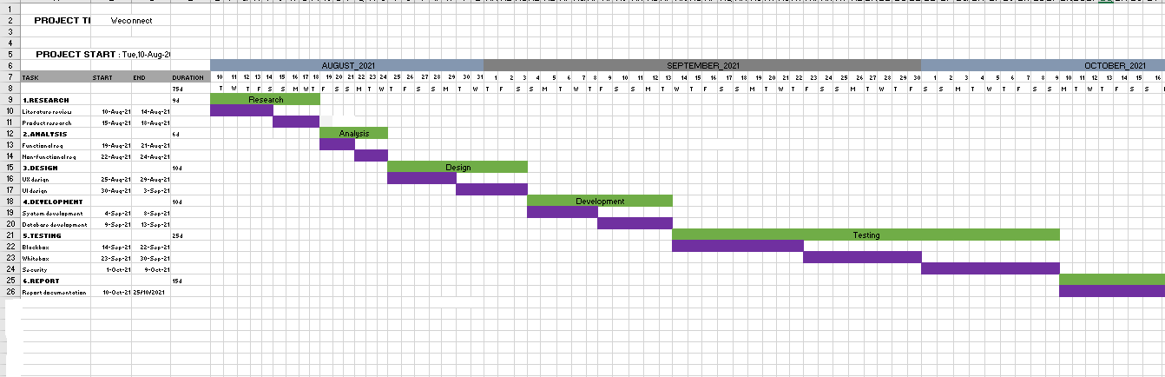 Gantt Chart

**Legal, ethical, social, professional issues and aspects**

During developing the product, it is important to consider and analyze the LESPI issues about the project. If LESPI issues are ensured then it can help project from many aspects such as deal with data loss, ensured privacy, handles critical situations, ensured users privacy, increased system reliability etc. This term also emphasizes on safety of intellectual information so that the data will be trans parented to user. Moreover the project should be ensured that the LESPI issues are considered and maintained properly because the future success of the product depends on it. Considering the LESPI issues will secure the project legally, socially, ethically and professionally.